Project Planning Phase
Project Planning Template (Product Backlog, Sprint Planning, Stories, Story points)

Date | 6 July 2026
Team ID
Project Name | ShopEz E-Commerce Application
Maximum Marks | 5 Marks

Product Backlog, Sprint Schedule, and Estimation (4 Marks)
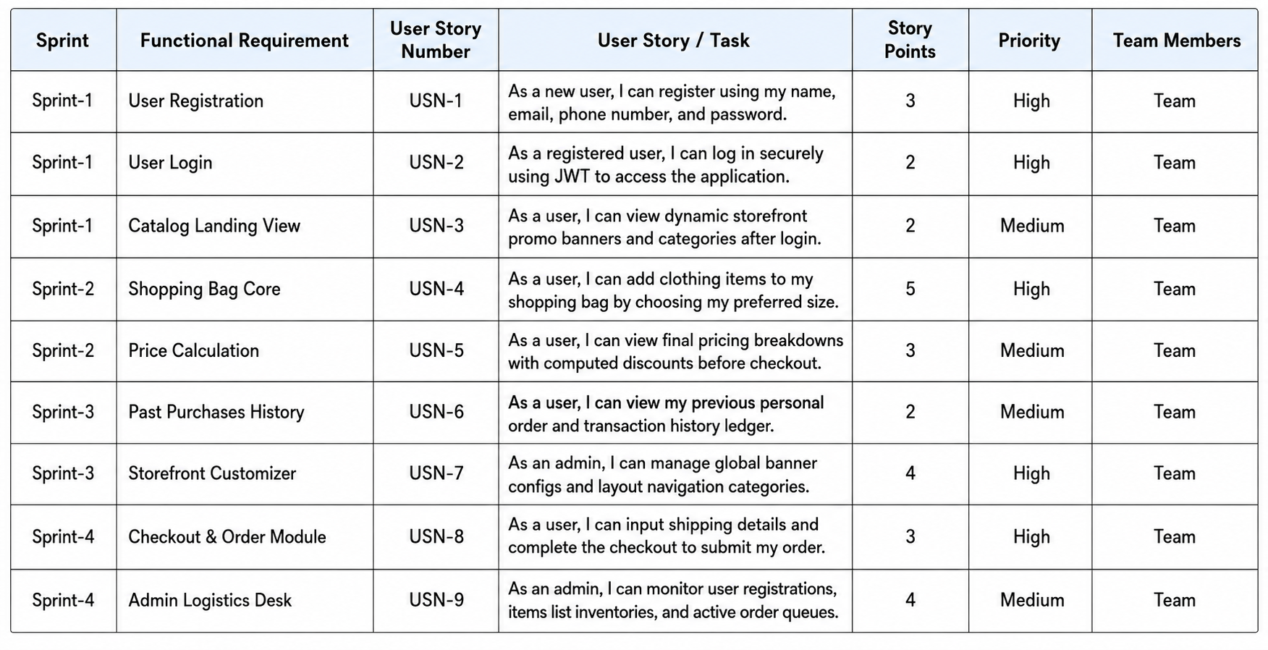
Project Tracker, Velocity & Burndown Chart: (4 Marks)
Sprint | Total Story Points | Duration | Sprint Start Date | Sprint End Date | Story Points Completed | Sprint Release Date
Sprint-1 | 20 | 6 Days | 03 Jul 2026 | 08 Jul 2026 | 20 | 08 Jul 2026
Sprint-2 | 20 | 6 Days | 09 Jul 2026 | 14 Jul 2026 | 20 | 14 Jul 2026
Sprint-3 | 20 | 6 Days | 15 Jul 2026 | 20 Jul 2026 | 20 | 20 Jul 2026
Sprint-4 | 20 | 6 Days | 21 Jul 2026 | 26 Jul 2026 | 20 | 26 Jul 2026

Velocity:
Imagine we have a 10-day sprint duration, and the velocity of the team is 20 (points per sprint). Let’s calculate the team’s average velocity (AV) per iteration unit (story points per day)

Burndown Chart:
A burn down chart is a graphical representation of work left to do versus time. It is often used in agile software development methodologies such as Scrum. However, burn down charts can be applied to any project containing measurable progress over time.

https://www.visual-paradigm.com/scrum/scrum-burndown-chart/
https://www.atlassian.com/agile/tutorials/burndown-charts
Reference:
https://www.atlassian.com/agile/project-management
https://www.atlassian.com/agile/tutorials/how-to-do-scrum-with-jira-software
https://www.atlassian.com/agile/tutorials/epics
https://www.atlassian.com/agile/tutorials/sprints
https://www.atlassian.com/agile/project-management/estimation
https://www.atlassian.com/agile/tutorials/burndown-charts

